September Newsletter

**Dates to Remember**

**Sept 4 9:00 a.m. Worship Service**

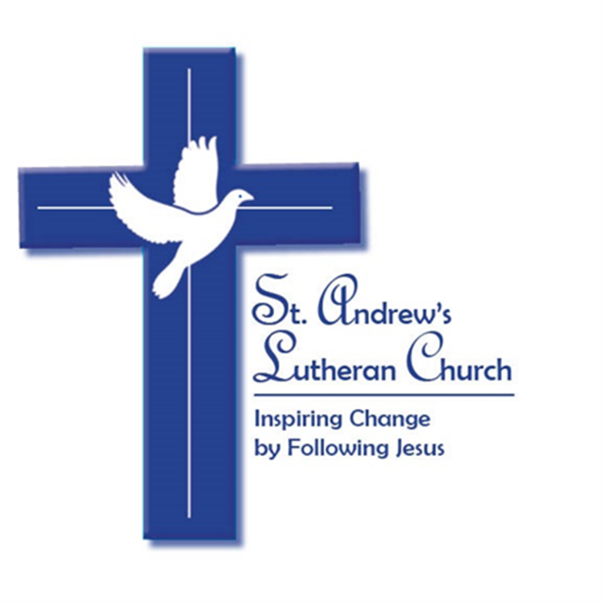

**Sept 8 6:00 p.m. Life Commission**

**7:00 p.m. Guatemala Mission Meeting**

**Via Zoom**

**Sept 11 10:00 a.m. Worship Service**

**Live and Zoom**

**Sept 15 7:15 p.m. Church Council**

**Sept 18 8:30 a.m. Worship Service**

**10:00 a.m. Worship Service Live and Zoom**

**11:30 a.m., Confirmation Parent/Kid Meeting**

**Sept 24-25 Produce Sale (hours TBD)**

**Sept 25 8:30 a.m. Worship Service**

**10:00 a.m. Worship Service Live and Zoom**

**PASTOR’S MESSAGE**

**Family of Faith at St. Andrew’s,**

I hope your summer has been a time of refreshment and relaxing. Now the back-to-school gear is in the stores, and we are looking ahead. We have an exciting chapter of life together coming up. On Sept 11, we will celebrate, “Reconnect Sunday” this will be an opportunity to come back to church, revive relationships and get intentional with our faith. Reconnect Sunday will kick off 6 weeks of focusing and recommitting to our faith.

I ask you to take this opportunity to Reconnect with St. Andrew’s. Commit to church participation for these 6 weeks. Let’s see where God is taking us. Come along for the journey! We will begin this journey in worship, the kids will meet their Sunday School teachers and a picnic will bring everyone together.

Looking further down the road we are working on an adult mission trip to San Lucas Toliman Guatemala in January, a multi-generation mission trip to Appalachia in July and a loaded season of worship and praise for all. Buckle up, this will be a great ride.

**Pastor Dave**

**COUNCIL NOTES**

**August 2022**

* Rally Day is Sunday, September 11, and we will all join together for one indoor service at 10 a.m. followed by our annual picnic.  Volunteers would be appreciated for help setting up tables and chairs and a sign-up sheet will be available after Sunday services.
* Beginning September 18 we will return to two indoor services at 8:30 a.m. and 10 a.m.
* Our Sunday School is growing! This means we are in need of teachers to help the youth of St. Andrew's grow in their faith and have fun doing so.  Please speak with Sue Epting to learn more (914-715-9546, [epting.susan@gmail.com](mailto:epting.susan@gmail.com)).
* Maryel School opens to students on September 8.  Please use the choir door (south entrance) during school hours Monday - Friday 7:30 a.m. to 6:00 p.m.
* There are many ways you can participate in the life of St. Andrew's.  There will be more information in the weekly Sunday bulletins, and all of us on Council are also available to help

**OUTREACH**

**Reconnect Sunday Picnic**

Sunday Sept 11 we are having one service at 10:00am followed by a church wide BBQ. Food, drinks, and ice cream provided as well as activities for children. Please join us to reconnect with our church family!

**Neighborhood letters**

The Outreach Committee is sending out 50 Welcome letters from Pastor Dave and St. Andrews to new residents of Yorktown in hope that we can find new members. We are using Zillow.com to get addresses of real estate sales (new residents). If any of our congregation are aware of a new resident in town, please give the address to Chuck Farrell and we will get a letter out to those folks.

### SUNDAY SCHOOL UPDATE

### Welcome back to Sunday School for the 2022-23 school year! We are all looking forward to seeing the children’s smiling faces at Reconnect Sunday on September 11th. Let’s all rally to kick off another year of exciting activities as we reconnect to learn about Jesus and his teachings. We are planning special events and crafts throughout the year to supplement the traditional lessons. And we plan to add lots of photos showcasing the children and their work in The Message!

### Registration forms, calendars, and other important information will be e-mailed to families but as always, please reach out to me at 914-715-9546 or via e-mail if you have questions, suggestions, etc. All children ages 3 through 7th grade are welcome.

### We are in need of teachers and helpers as our goal is to have team teaching so staff can attend church on alternating Sundays. It doesn’t take that much of your time and you get back much more than you give! We also welcome anyone who would like to do a special lesson or craft with the children or assist with events such as the annual Christmas pageant. Again, please reach out to me with any questions.

### Enjoy the rest of the summer and we look forward to seeing all of you on September 11th!

### God Bless,

### Sue Epting, Sunday School Superintendent

### FINANCIAL UPDATE

### 

**In Our Prayers**

|  |  |  |  |
| --- | --- | --- | --- |
| Barakel Adera | Paige DeRiggi | Joseph Knapp Sr. | Nicole Safron |
| Barbara Louise Brooks | Alexa Ferrara | Paul Locken | Asher Session |
| James Byrne | Linda Greco | Joanne McCarthy | Betsy Valentin |
| Daniela Pace DeLeo | Joseph Hayes | Karen McIntyre | Rudy Valentin |

|  |
| --- |
| **Wrestling with long-term health issues** |

|  |
| --- |
| **Hospitalized or recuperating** |

|  |  |  |  |
| --- | --- | --- | --- |
| Maria Adessa | Kate Epting-Harris | Roseann Lella | Mike Raffia |
| Nancy Calandra | Anna Errico | Christina Morris | Tom Riordan |
| Chuck Cassidy | Joanna Falcone | Mary Kay McNamee | Mary Schuster |
| Jonathan Cope | Judy Gordon | Robin Muller | Ralph Schuster |
| Andrea Cummings | Mary Gus | Lucille Oricchio | John Smith |
| Anthony DeRosa | Tom Gurba | Liz Prinz | Peggiann Thorp |
| Debbie Dubois | Laura Heiss | Anita Porter | Bella Tufano |
| Doug Dubois | John Kellett | Holly Quarles | Brad Wheeler |
| Jen Epting Dary | Mike Lekhmus | Rick Raggi | Lisa Wheeler |

|  |
| --- |
| **Facing life’s challenges** |

|  |  |  |  |
| --- | --- | --- | --- |
| Alyssa Billingsley | Eric Enriquez | Daniel King | Ann Robertiello |
| Chuckie Cassidy | Cathleen Famular | Sarah Prinz | Joanne Sayles |
| Devon Crispell | Mark Graff, Jr. & Family | Sean Prinz | Cathy Souza |
| Dominic Enriquez |  |  |  |

|  |
| --- |
| **Mourning the passing of** |

|  |  |  |  |
| --- | --- | --- | --- |
| Charlotte Hamm | Cindy Berg Sauter | Beryl Zapp | Stanley Pulver |
| Delores Shuler | Helen O’Brien | Rob Bellamy | Norbert Lucas |
| Audrey Conlon | Edith Raspuzzi | Ed O’Connell | Rob Reynolds |
| Ingrid Frank | Ed Gavard | Ruthanne Boggs | Paul Kristoffersen |
| William Hamm | Robert Badalamenti | Ann Johnson |  |

|  |  |  |  |
| --- | --- | --- | --- |
|  |  |  |  |
|  |  |  |  |
|  |  |  |  |
|  |  |  |  |

|  |
| --- |
| **Serving in the Military** |

|  |  |  |  |
| --- | --- | --- | --- |
| Randy Bacon | Paul Fosse Jr. | Kenneth Holman | Michael J. Tillistrand |
| Daniel Bendetti | Gregory Gonzalez | Michael Lawless | Alex Wood |
| Brandon Cintron | Tajae Hickson | Randal Middleton | Jayson Zuluaga |

|  |
| --- |
| **Restricted to home/nursing facilities** |

|  |  |  |  |
| --- | --- | --- | --- |
| Norlene McAuliffe | Mary Shepard | Gus Hellman |  |

|  |
| --- |
| **Residents of Jan Peek** |

|  |
| --- |
| **Our Bishop** |

Rev. Paul Egensteiner

Please call or email the office to place someone on or remove someone from the

Prayer List. Thank you.

|  |
| --- |
| **Our Missionaries** |

Dr. Stephen J. and Jodi Swanson

*Revised 8-25-22

****